- Introduction

  - Purpose:

This document provides the design for implementation of Mobile billing using message passing. This also includes the architecture features of the system.

  - Scope:

The scope of the system can be listed as follows:
- Call rates are assumed to be uniform
- PULSE duration is assumed to be per second pulse.

  - Overview:

This document describes the architectural model used for the system giving the Data design and system architecture models for the system to be developed.

  - References:

www.wikipedia.com/messagepassing/main.php
www.unixtalks.com/index.html
www.mpiprogramming.com/1.php

1.5 Definitions , Acronyms , Abbreviations:

MPI: Message Passing Interface
IPC: Inter Process Communication

Definition:
Message passing in computer science, is a form of communication used in parallel computing, object-oriented programming, and inter-process communication. In this model processes or objects can send and receive messages (comprising zero or more bytes, complex data structures, or even segments of code) to other processes. By waiting for messages, processes can also synchronize.

- System Overview:

Message passing is a style of IPC in which processes containing data or simply an identification tag can send discrete messages directly to one another. The mobile billing system implemented can be viewed to be comprising of two modules, the client and the server module.
The client module makes a request for either calling or bill generation and the server module acknowledges both the type of requests and replies by generating the bill or updating the database.

- System Architecture:

Consider normal scenario wherein a client requests for a service to the server:
- A function call passes a message from the client to the server to either establish a call request or generate a bill.
- The client information is stored in some part of the memory . The server accesses this memory to fulfil the client request and later the process is repeated by the server to the client to acknowledge the service, which is also implemented using message passing.

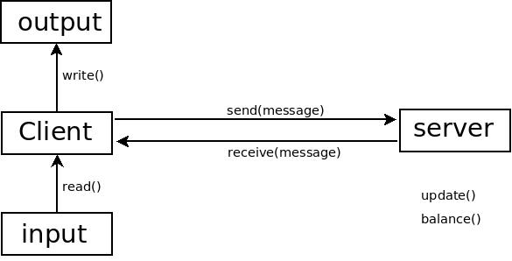

Fig.1. showing the System Architecture for the application to be developed.

- DATA DESIGN:

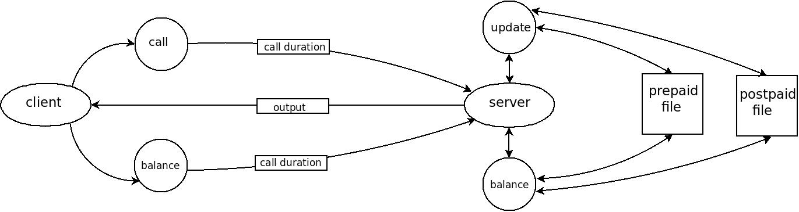
Fig.2. Showing The Data Flow Diagram Of the System To Be Developed.

  - Data Dictionary:

Update=bill+(units*price)
Update=bill-(units*price)

  - Description:

- Call Request:
The phone number is input by the user which is obtained by the client process using the read() function. The client process in turn provides a message to the server process to start the call timer.

- Call Termination:
After the call request is made, again the client process later sends a message to the server process to stop the call timer thus knowing the call duration. This data is then updated in the database terminating the actions required for the calling request.

- Billing Request:
A request by the client for the bill generation is passed to the server using message passing. The server interacts with the corresponding files and once the required data is obtained it sends the data to the client process using message passing.

